**YLDP Session with Nidhika Mehta & Mike Akel**

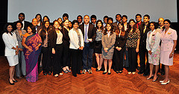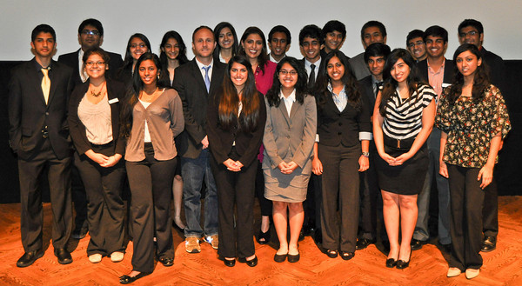

On Sunday, May 6th, 2012, the YLDP of Houston met at the Museum of Fine Arts of Houston for its eighth and final classroom session on the theme of social, culture, and art. The students had the opportunity to meet and hear from Nidhika Mehta, a well known philanthropist and patron of the MFHA as well as Asia Society and Mike Akel, a popular teacher at the Kinkaid School, who spoke to them about his passion for the art of film making. Students also received a guided tour of the Asian art galleries in the museum and had the chance to learn about art from Korea, China, Japan, and India.

Nidhika Mehta demonstrated her appreciation for the Indian culture and desire to enlighten Houstonians of the rich, varied background of India. Mehta spoke of her upbringing in the Middle East and how exposure to different environments helped form the person that she is today. She emphasized that taking the first step was the most important obstacle to overcome in pursuing goals in life. She says, "One cannot do everything, but everyone together can do one thing". If everyone could just play a small role in helping others in need, that helping hand in turn creates a long lasting change. She encouraged all students to recognize their passion in life and to never accept failure in regard to one’s vision.

Mike Akel challenged YLDP students to recognize what makes them “come alive”, adding that what the world needs is “people who have come alive”. He showed that one’s passion does not have to be incredible; it simply has to be something that one can make a difference with. He encouraged students to take the first step into achieving their dreams, because one “can’t steer a parked car”- one must start the ignition. Mr. Akel also explained that movies are a reflection of society; as they narrate and show how to respond to certain situations making us cry, laugh, as well as examine current times.

Movies are a way to relate to other cultures as well. Art works from ancient to the contemporary staying true to origins and values of the times; art conveys the message that we are all one. As a leader we must respect other cultures and strive to broaden our horizons, and create a safe environment for all.

YLDP students Enakshi Ganguly, Priya Bhattacharjee, Rajni Bhavsar, Anuva Kachru, Gaurav Dhume, Akshay Rajan, and Isha Deo contributed to this article